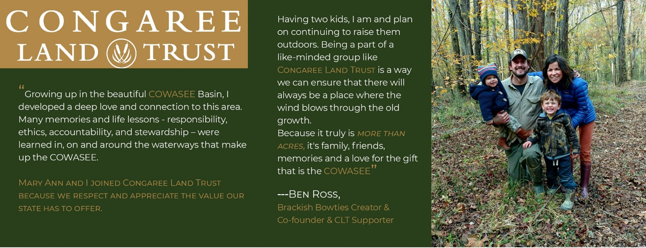
/

I WOULD LIKE TO RENEW MY SUPPORT TODAY!
DONOR LEVELS: $35 / $50 / $100 / $250 / $500 / $700 / $1000

I would like to renew at: __________________
DONOR INFO:

Name (please print): ____________________________________________________________________________________________

Address: __________________________________________________________________________________________________________

City, State, Zip: ___________________________________________________ Phone: _____________________________________

Email: _____________________________________________________________________________________________________________

I would like to renew at: __________________

I would like to make my donation in memory/honor of: ____________________________________________
Please send acknowledgement letter to: ________________________________________________________
RETURN THIS FORM WITH YOUR PAYMENT TO:
Congaree Land Trust
P.O. Box 5232
Columbia, SC 29250
Name (please print): _____________________________________ Address: _______________________________________________
City, State, Zip: __________________________________________
Phone: ________________________________________________
Email: _________________________________________________

PAYMENT METHOD (circle):
Renew online for membership and monthly giving options!
www.congareelt.org
VISA Mastercard Amex Check (enclosed)
Card number:__________________________________________
Expiration Date: _______________ CVV: _________________
Congaree Land Trust | P.O. Box 5232 | Columbia S.C. 29250 | carla@congareelt.org | 803.988.0000

